**E0121033 Mohammed Zahan**

Sum of profits in a graph

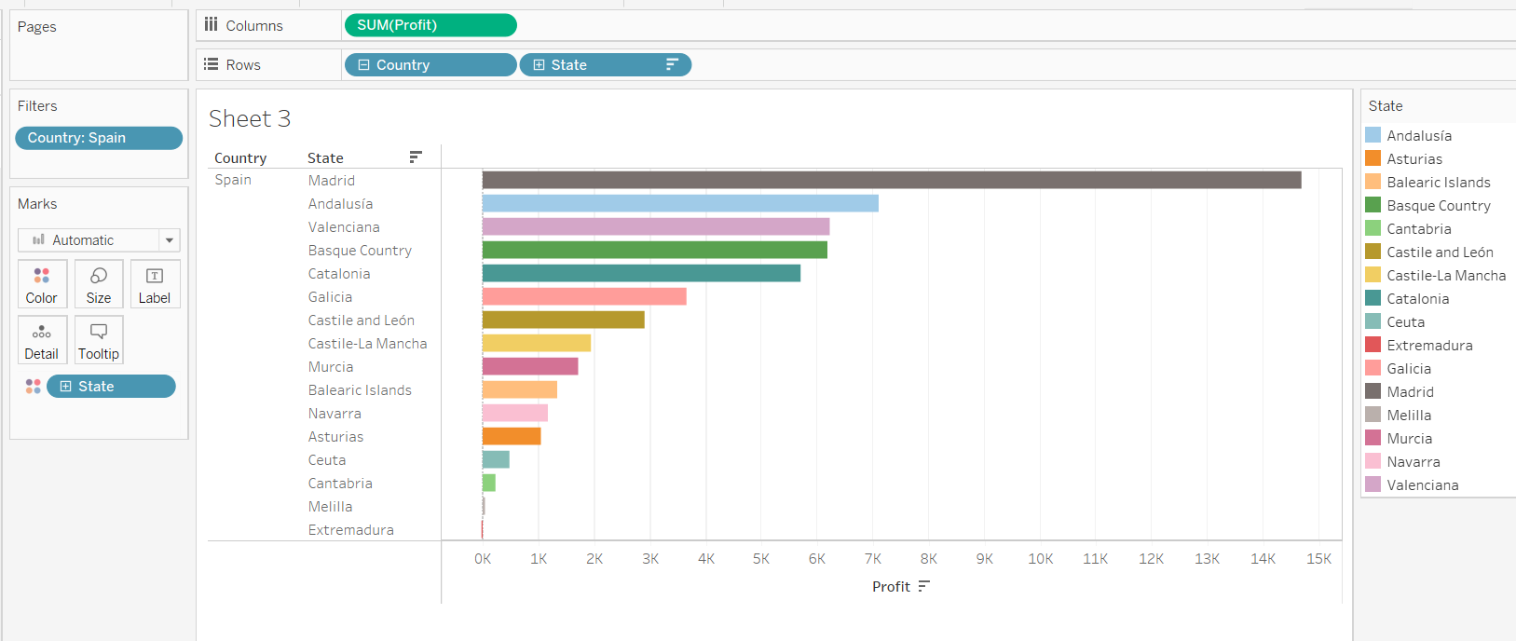

Sum of profits in geo maps

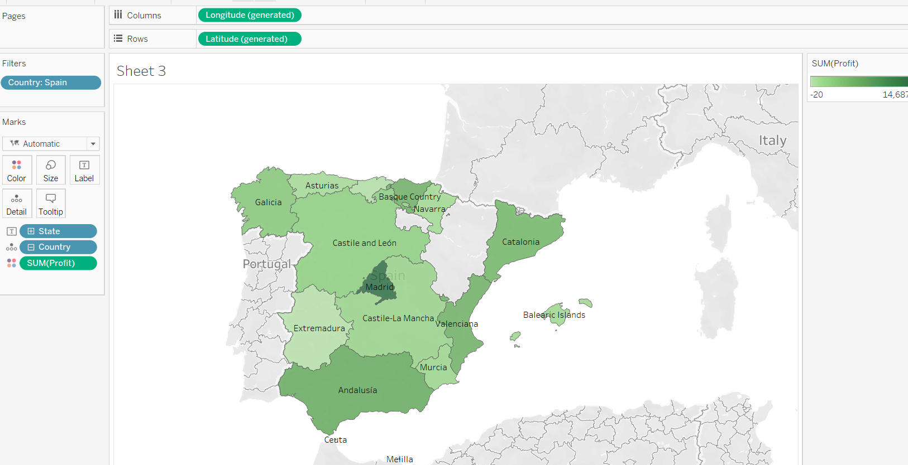

Sum of profits in geo graph with shapes

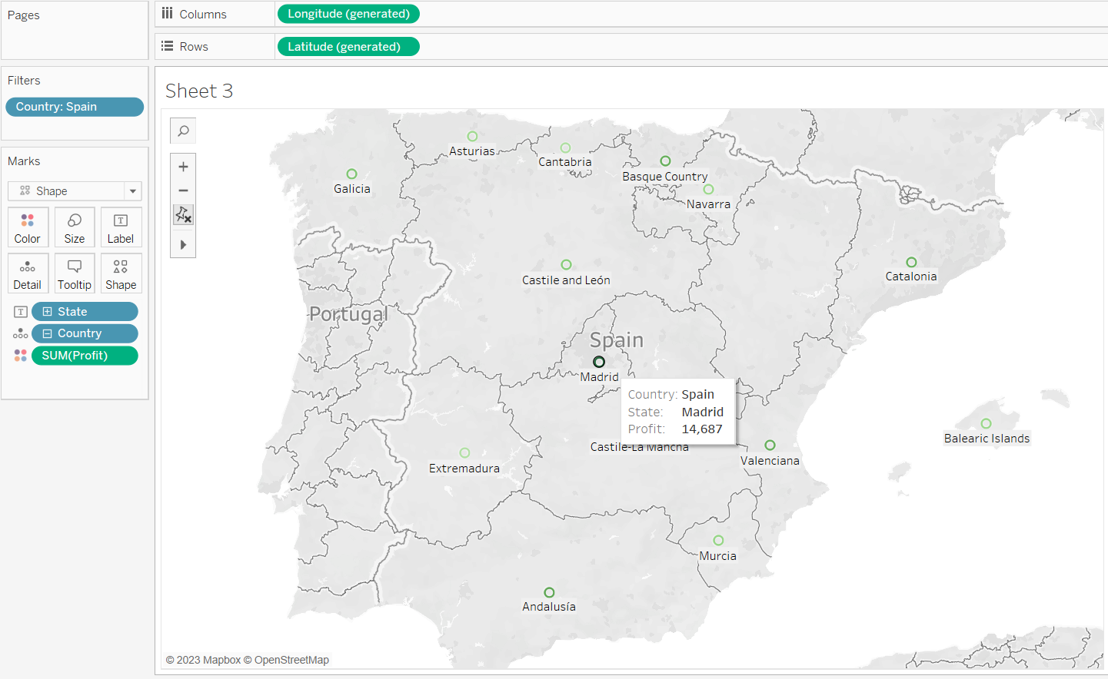

Sum of profits in geo maps with different shapes

